Pingall:
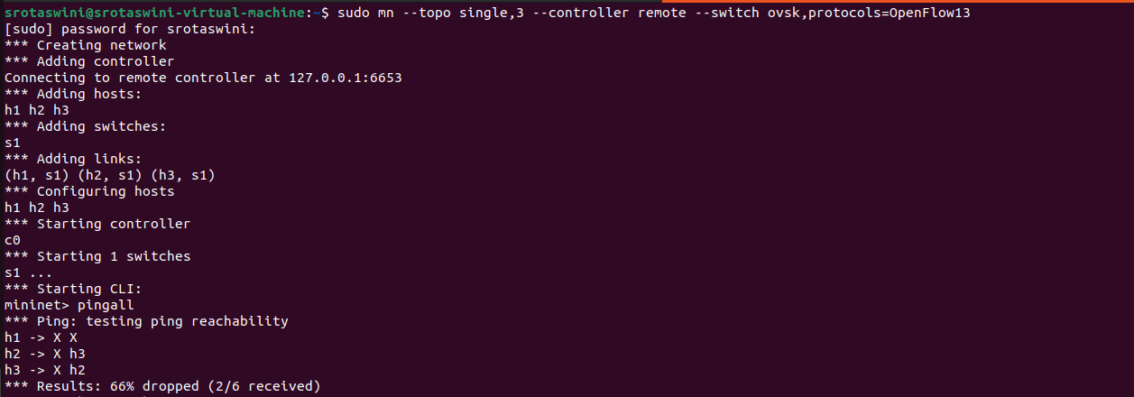
H1 ping h2:
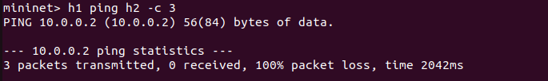
H2 ping h3:
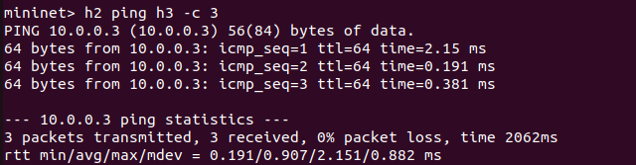
Iperf:
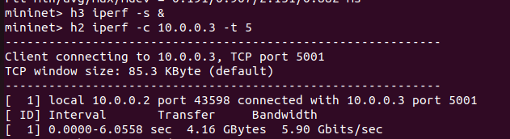

Flow table:
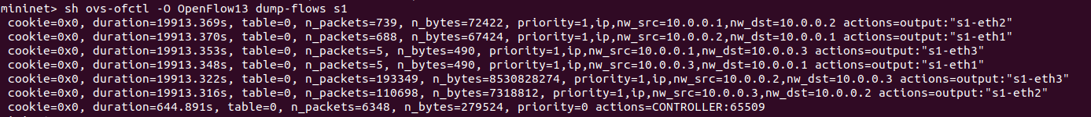
Ryu terminal:
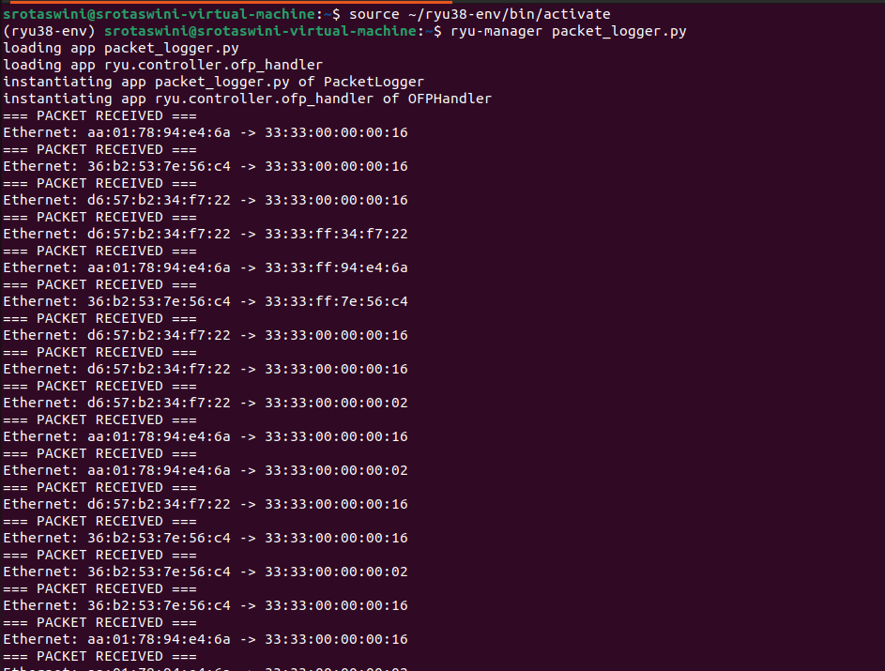
Wireshark:
